Batch: D1 Roll No.:16010122088

Experiment / assignment / tutorial No._______

Grade: AA / AB / BB / BC / CC / CD /DD

Signature of the Staff In-charge with date

Experiment No.:9

TITLE: Study and configure DHCP & DNS protocol using Cisco Packet tracer

AIM: To study and configure DHCP/DNS protocol using Cisco Packet tracer
_____________________________________________________________________________
Expected Outcome of Experiment:
CO:

_____________________________________________________________________________
Books/ Journals/ Websites referred:
- A. S. Tanenbaum, “Computer Networks”, Pearson Education, Fourth Edition
- B. A. Forouzan, “Data Communications and Networking”, TMH, Fourth Edition
_____________________________________________________________________________
Pre Lab/ Prior Concepts:
IPv4 Addressing, Subnetting, Link State Protocol, Router configuration Commands
_____________________________________________________________________________
New Concepts to be learned: DHCP/DNS Protocol and its configuration.
_____________________________________________________________________________

THEORY:

IMPLEMENTATION:

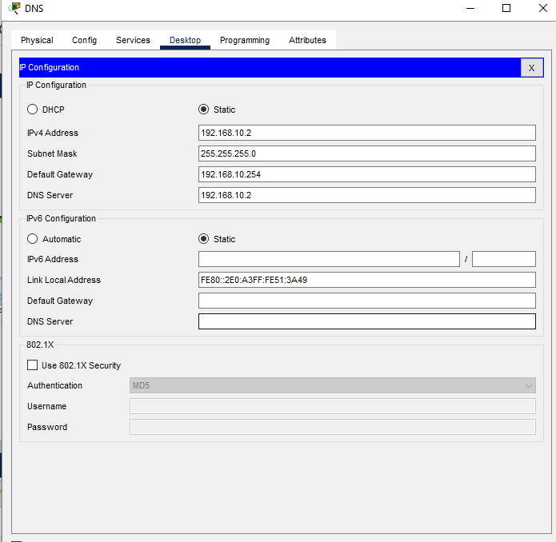

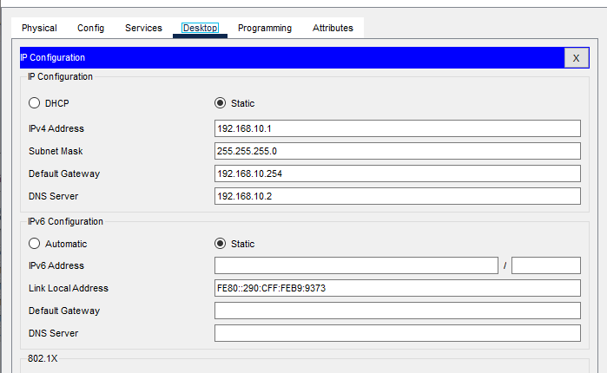
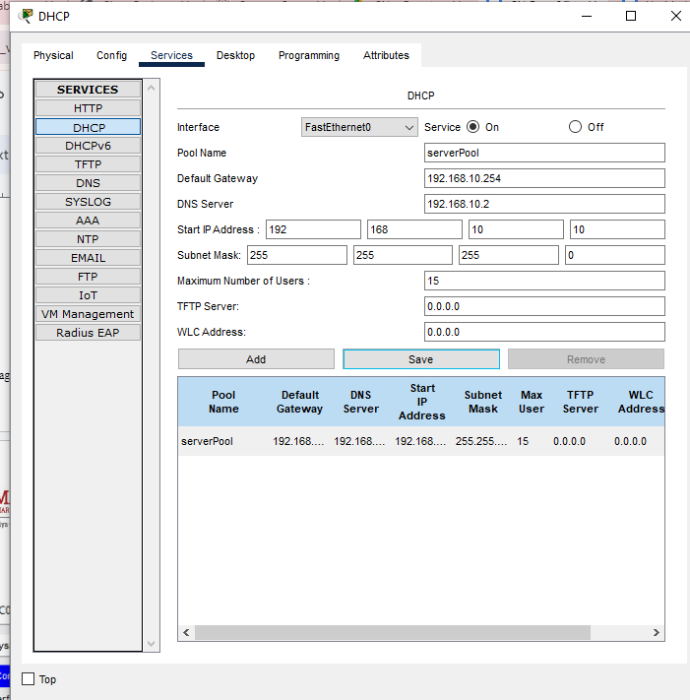

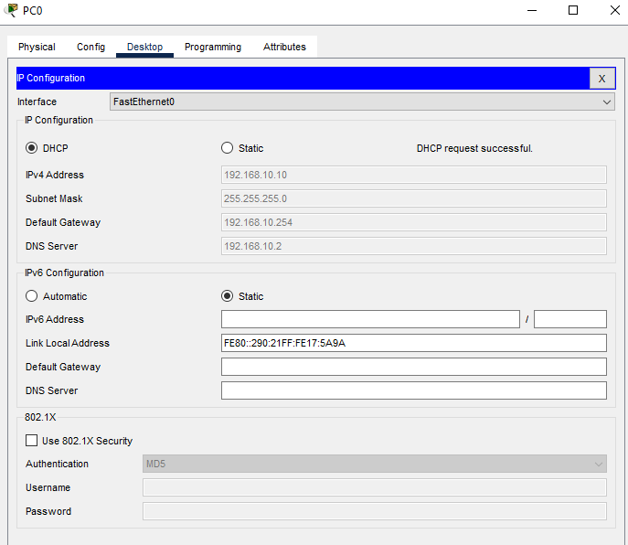
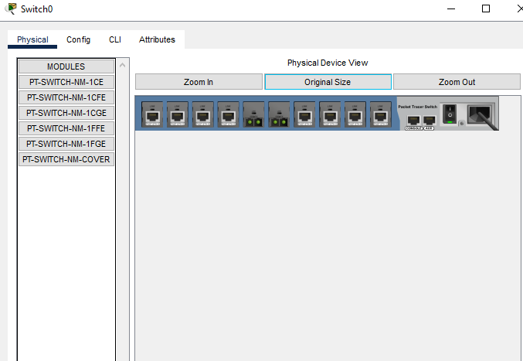
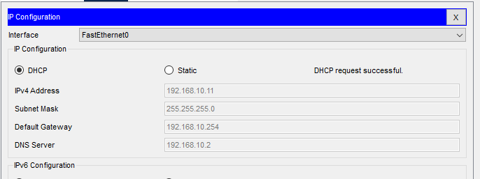
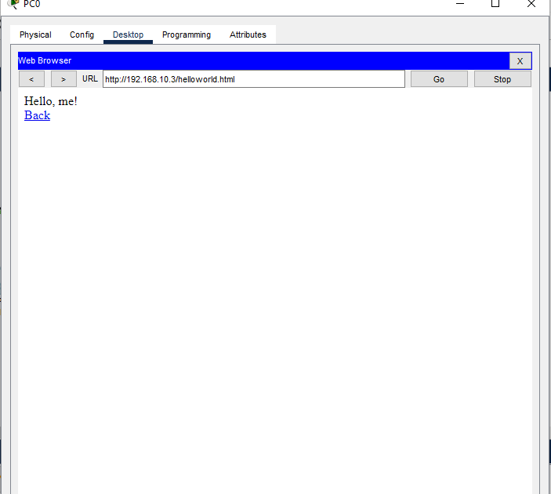
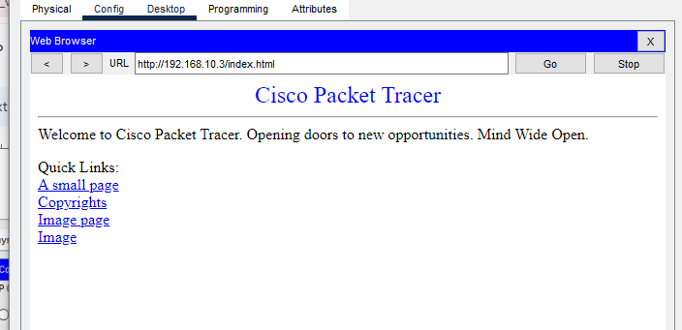
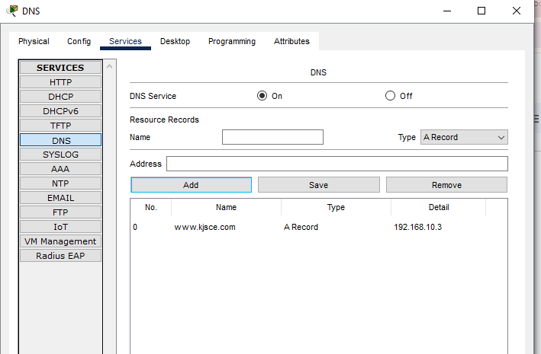

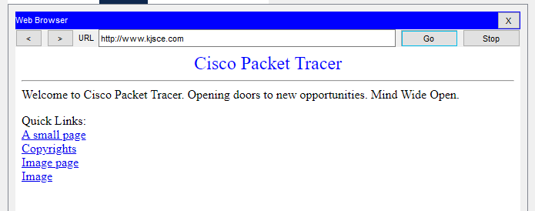

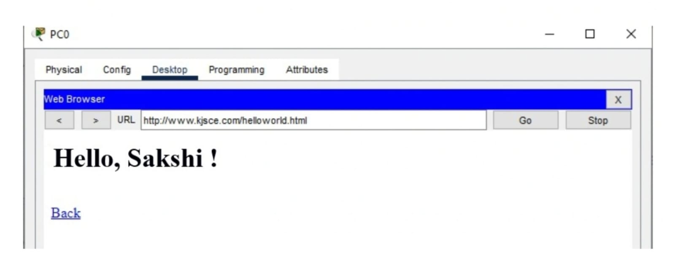

CONCLUSION:
We have learned about DHCP AND DNS servers

Date: 6th November, 2024 Signature of faculty in-charge

